Proff API
General information
Documentation is available online, https://api.proff.no
Some experience with API’s and Swagger is recommended.
You also receive documentation in your startup email. For example a list of financial codes used in some of the endpoints.
If you need additional copies of the documents from the startup email please contact support or your point of contact in the sales department.
Use
To perform queries you need an advanced REST client, Postman or equivalent software.
You can also test Proff API from a web browser, https://api.proff.no/swagger/index.html.
When testing Proff API in a browser remember to provide your unique token as authorization. See instructions below.
Example Postman:
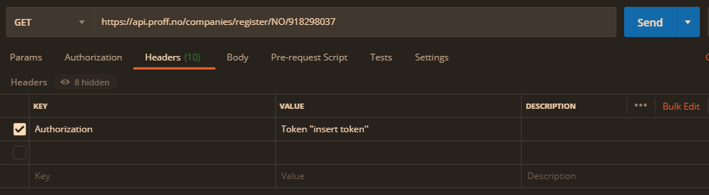
Example Swagger (https://api.proff.no/swagger/index.html):
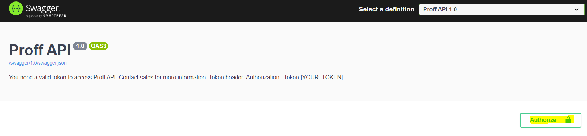
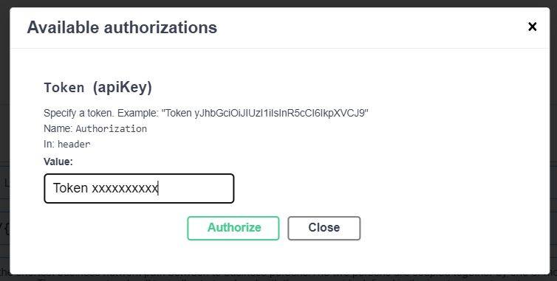
Support
In need of support with technical questions please send us an email with your questions.
Written inquiries are preferred as we need information on what data you wish to extract, examples of queries that fail, error messages etc. The information asked for above will provide us with the information we need to answer your questions. Some response time is expected.
Send the email to technical support and your point of contact at sales.
For other questions (rates, your contract, lookups or token renewal etc.) contact your point of contact at sales.
Main point of contact, technical support
Marit Foss
Technical Sales Support
Email: marit.foss@proff.no
Phone: +47 988 01 132
Secondary point of contact, technical support
Thomas Nylænder
Product owner
Email: thomas.nylaender@proff.no
Phone: +47 918 87 750
Use cases
To perform queries you need an advanced REST client, Postman, or equivalent software.
You can also test Proff API from a web browser, https://api.proff.no/swagger/index.html
Remember to provide your token as authorization as shown with examples in the use section of this document.
Four basic use cases are shown below
- Official Enterprise Information
- Industry code (NACE code) lookup
- Role holders
- Corporate structure
Official Enterprise Information
The endpoints RegisterCompany (register) and ProCompany (eniropro) provides company data and figures from the accounts. ProCompany is equivalent to the register search, but market data is included in the output.
Note that our API will show figures from 3 different accounts:
companyAccounts, the company's figures from accounts (recommended)
corporateAccounts, figures for the group
annualAccounts, a hybrid of companyAccounts and corporateAccounts where the figures from companyAccounts are prioritized if both company and group have submitted accounts.
RegisterCompany:
/api/companies/register/{country}/{id}
/api/companies/register/{country} - Provides opportunities for segmentation
ProCompany:
/api/companies/eniropro/{country}/{id}
/api/companies/eniropro/{country} - Provides opportunities for segmentation
Example register: https://api.proff.no/companies/register/NO/918298037
Output from this endpoint is general company information and figures from the accounts (included historic figures from accounts). A list of financial codes, specific for each country, is needed if you wish to extract financial data. The documentation referred to above is available online, https://apidocs.proff.no, or in your startup email.
Examples eniropro:
https://api.proff.no/companies/eniropro/NO/IF6QBAT0ZDF (ID = ListingID)
https://api.proff.no/api/companies/eniropro/NO?industry=918298037 (ID = Organization number)
https://api.proff.no/api/companies/eniropro/NO?name=Proff%20AS -> (ID = Companyname)
Output from this endpoint is also company information and figures from the accounts (included historic figures from accounts), but the output is enriched with market data. Note that you may need two lookups to find the data you are looking for and that a list of financial codes, specific for each country, is needed if you wish to extract financial data. The list of financial codes is available online, https://apidocs.proff.no, or in your startup email.
You can find the listingID by running a register query or in the output from another lookup.
/api/companies/register/{country}/{id} -> Keyword: "proffListingId"
https://api.proff.no/api/companies/eniropro/NO?industry=918298037 -> Keyword: "companyId"
https://api.proff.no/api/companies/eniropro/NO?name=Proff%20AS -> Keyword: ""companyId"
Please note that if a company has several Proff branches, the company will have several company ID’s, as shown in the picture below.
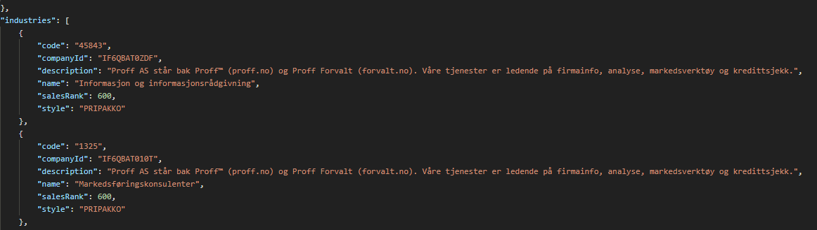
Industry code (NACE code) lookup
If you need to identify an industry code you can ask for all available industry codes.
Example:
/api/companies/register/businesscategories/{country}
https://api.proff.no/companies/register/businesscategories/NO
A description is given in "groupText" and the industry code in "id"
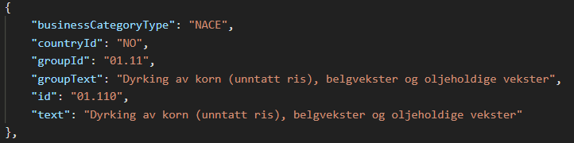
Example, lookup with industry code:
/api/companies/register/{country}
https://api.proff.no/api/companies/register/NO?industryCode=63.920&pageSize=25
Input in the query above is NACE code, but also additional input. The additional input are hits per page. Default page size is 10.
See Swagger, https://api.proff.no/swagger/index.html, for all available additional inputs.
Role holders
The RegisterCompany endpoint will provide role holder data for both person and company roles.
Example:
/api/companies/register/{country}/{id}
https://api.proff.no/api/companies/register/NO/918298037
Keywords: "personRoles" and "companyRoles"
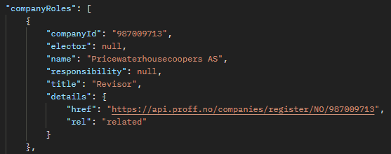
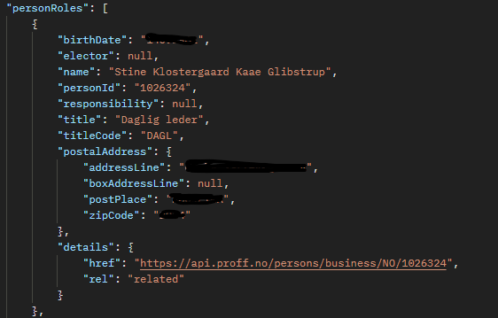
Once you have found a role holder's unique ID (''personId''), you can see all the roles this person holds with /api/persons/business/NO/personId.
For historical roles use the endpoint /api/companies/register/{country}/{id}/historicalRoles
Corporate structure
At the endpoint RegisterCompany you may look up a company’s corporate structure.
/api/companies/register/{country}/{id}/corporateStructure
For output example see Swagger, https://api.proff.no/swagger/index.html, and the responses section.
